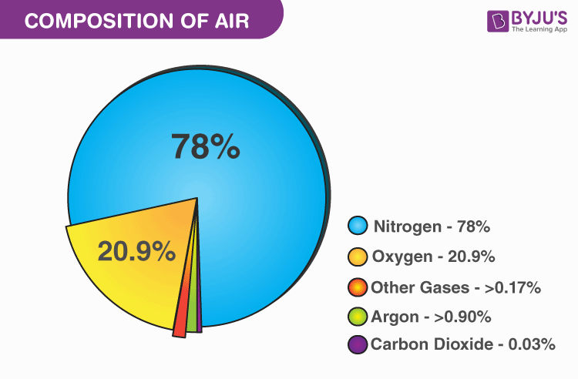

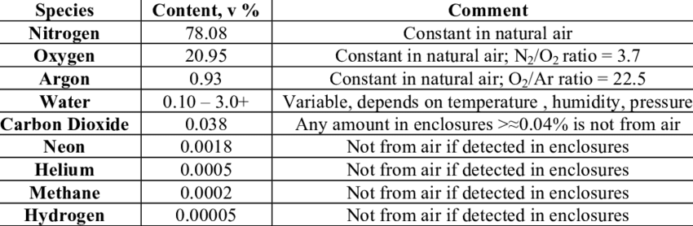

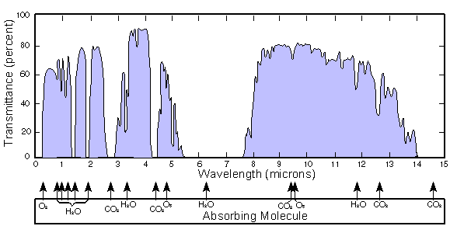

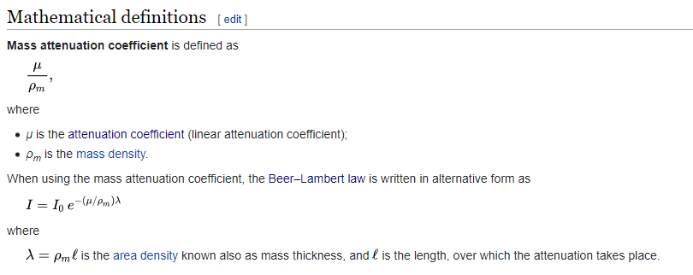

NIEUWE STRAT: 1342 NM

<https://eblanaphotonics.com/products/1342-dm/>

# Ik heb veel van deze site:

<https://scifinder-n.cas.org/searchDetail/reference/61542a626b8ea06197bf0f4e/referenceDetails>

<https://www-sciencedirect-com.tudelft.idm.oclc.org/science/article/pii/S0022407315302727?via%3Dihub>

<https://spectra.iao.ru/molecules>

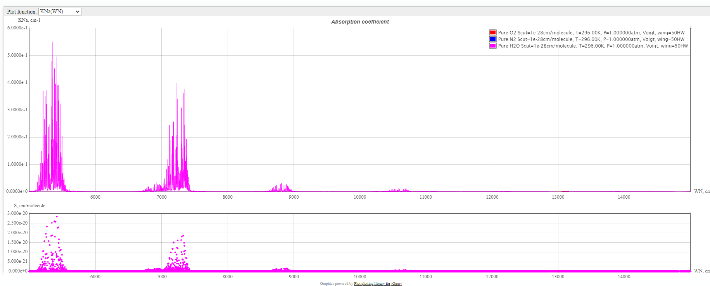

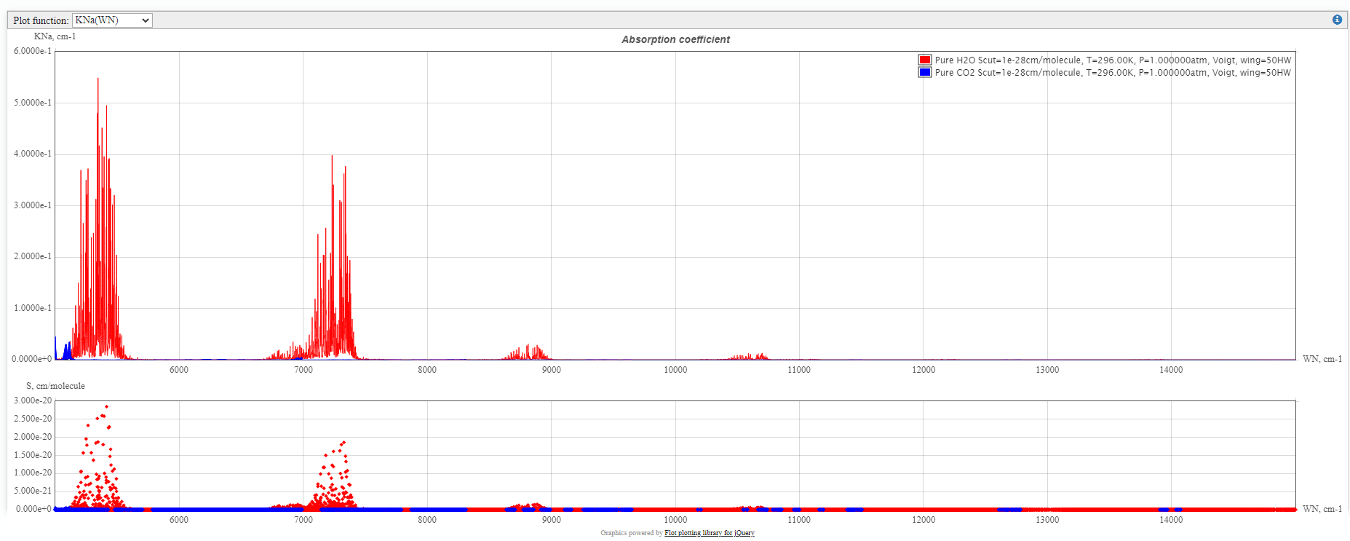

# Oxygen

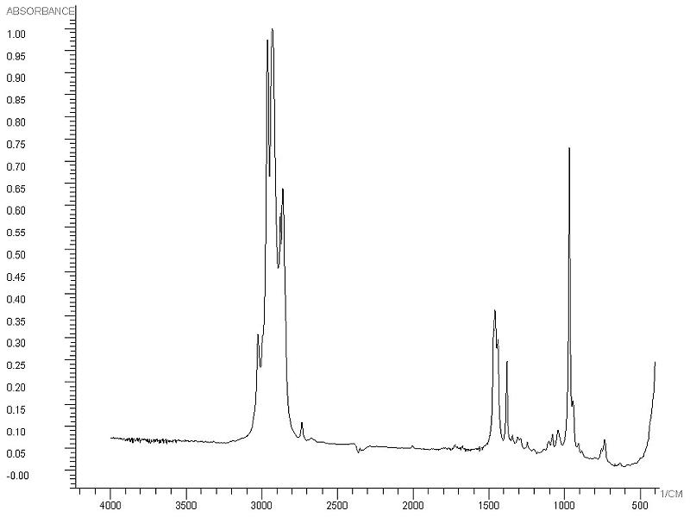

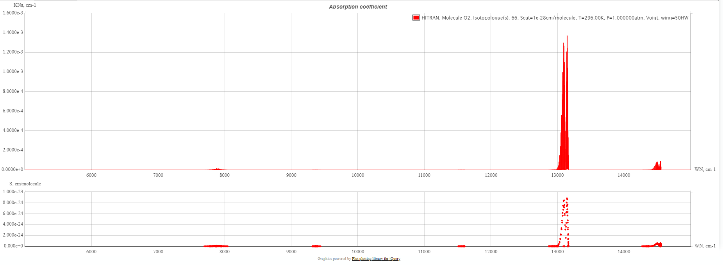

# Nitrogen

# 

Of 0 volgens spectra

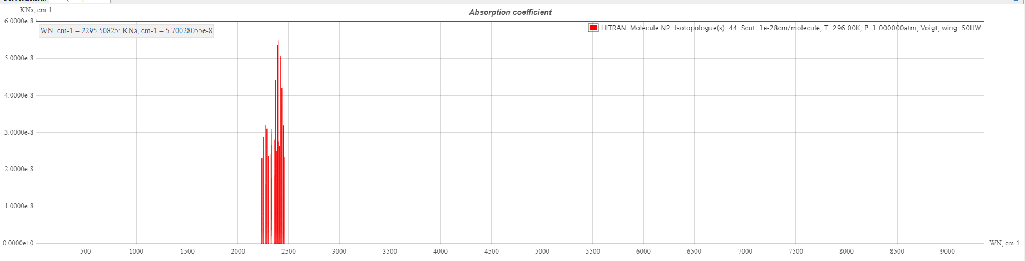

# H2O

# 

Water:

wavelength: 718 nm, attenuation coeff: 1

wavelength: 810 nm, attenuation coeff: 1.5

wavelength: 1130 nm, attenuation coeff: 20

wavelength: 1380 nm, attenuation coeff: 30

wavelength: 1888 nm, attenuation coeff: 900

wavelength: 2680 nm, attenuation coeff: 8000

wavelength: 6300 nm, attenuation coeff: 15000

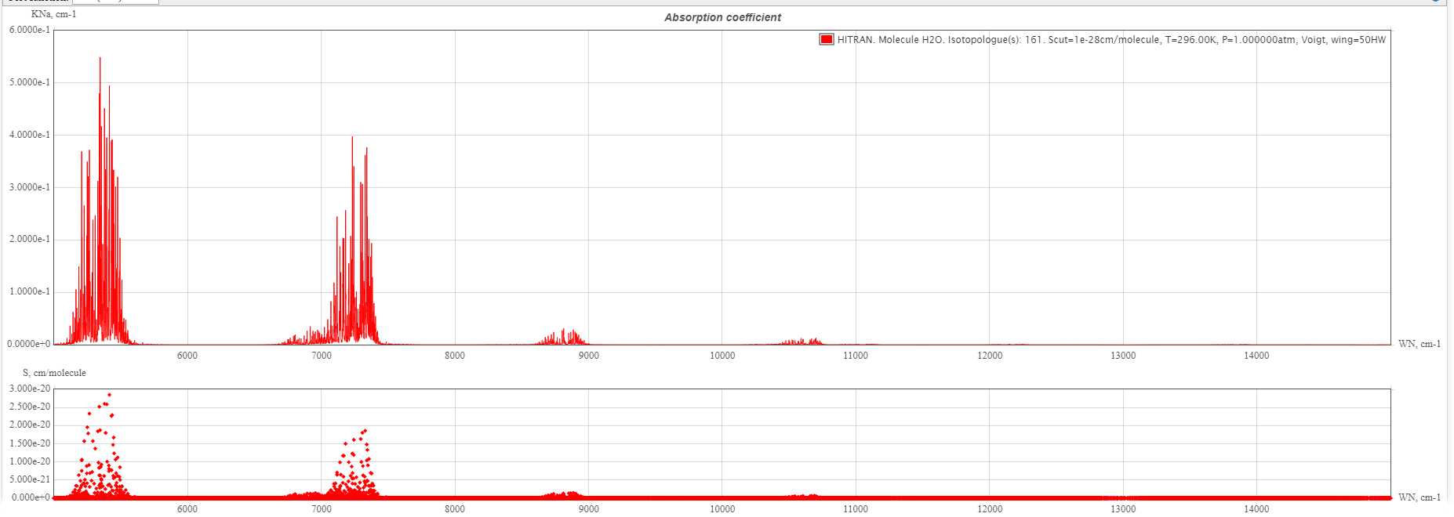

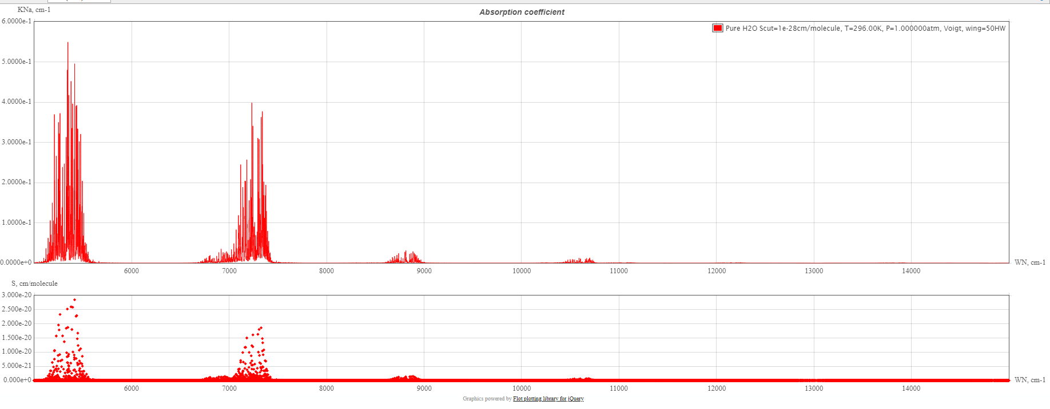

# 

# Argon

# 

# CO2

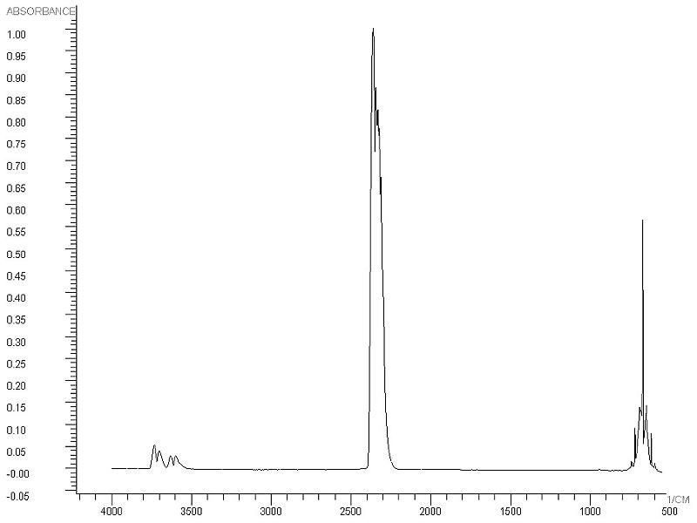

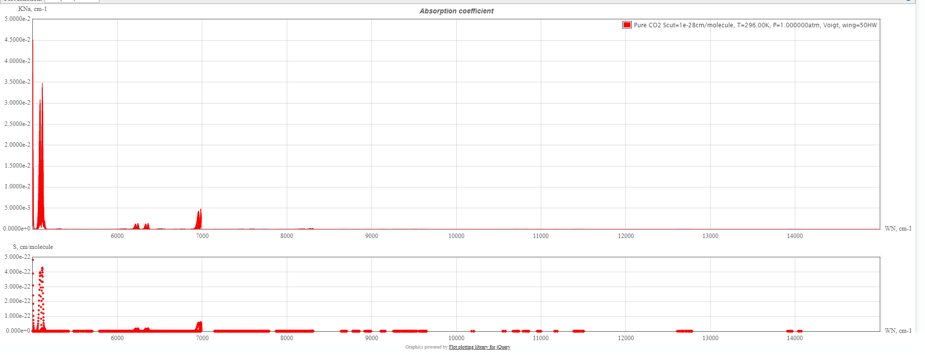

# Attenuation coeffs FOUT (behalve water)

<https://physics.nist.gov/PhysRefData/XrayMassCoef/ElemTab/z07.html>

Nitrogen:

wavelength: 1242.38 nm, attenuation coeff: 384.27

wavelength: 828.25 nm, attenuation coeff: 125.58

wavelength: 621.19 nm, attenuation coeff: 55.35

wavelength: 414.13 nm, attenuation coeff: 16.90

wavelength: 310.59 nm, attenuation coeff: 7.16

wavelength: 248.47 nm, attenuation coeff: 3.65

wavelength: 207.06 nm, attenuation coeff: 2.10

Oxygen:

wavelength: 1242.38 nm, attenuation coeff: 603.13

wavelength: 828.25 nm, attenuation coeff: 203.54

wavelength: 621.19 nm, attenuation coeff: 91.31

wavelength: 414.13 nm, attenuation coeff: 28.53

wavelength: 310.59 nm, attenuation coeff: 12.24

wavelength: 248.47 nm, attenuation coeff: 6.29

wavelength: 207.06 nm, attenuation coeff: 3.64

Argon:

wavelength: 1242.38 nm, attenuation coeff: 522.49

wavelength: 828.25 nm, attenuation coeff: 181.33

wavelength: 621.19 nm, attenuation coeff: 84.02

wavelength: 414.13 nm, attenuation coeff: 27.95

wavelength: 310.59 nm, attenuation coeff: 124.26

wavelength: 248.47 nm, attenuation coeff: 69.33

wavelength: 207.06 nm, attenuation coeff: 42.55

Water:

wavelength: 718 nm, attenuation coeff: 1

wavelength: 810 nm, attenuation coeff: 1.5

wavelength: 1130 nm, attenuation coeff: 20

wavelength: 1380 nm, attenuation coeff: 30

wavelength: 1888 nm, attenuation coeff: 900

wavelength: 2680 nm, attenuation coeff: 800

wavelength: 6300 nm, attenuation coeff: 15000